Lab 05 – Worksheet

Name: Mohammad Husain Naqvi  Syed Fakhar Iqbal Rizvi | ID: 11062  11091 | Section: T-4

Note: Assumptions and logics should be explained separately in tasks after the task results.

Task 1
FSM:
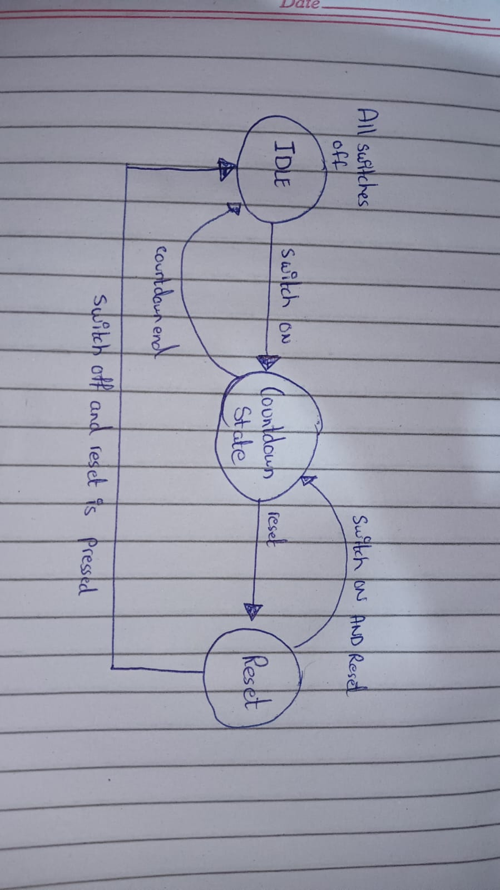

Comments

Task 2

Modules + Testbench:
TOP MODULE:
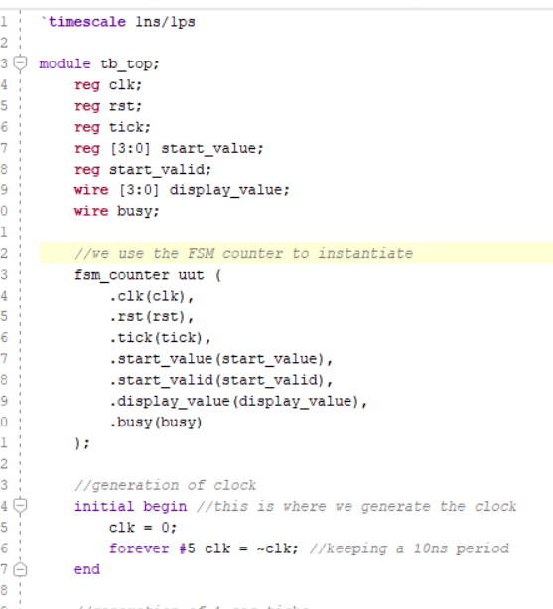

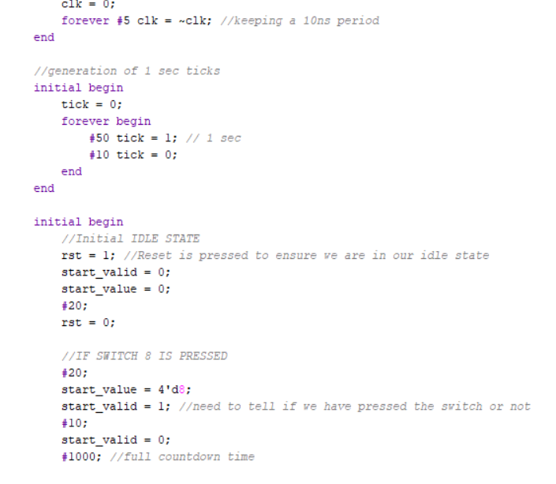

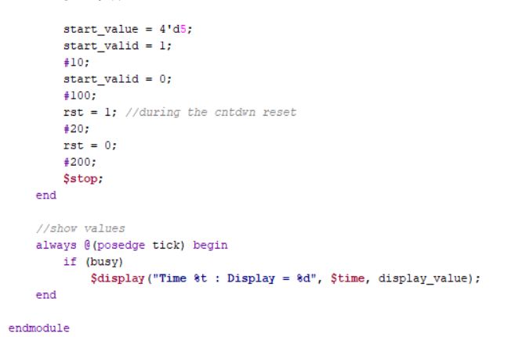

De-bouncer:
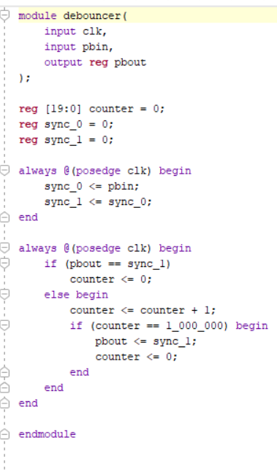

module debouncer(
input clk,
input pbin,
output reg pbout
);

reg [19:0] counter = 0;
reg sync_0 = 0;
reg sync_1 = 0;

always @(posedge clk) begin
sync_0 <= pbin;
sync_1 <= sync_0;
end

always @(posedge clk) begin
if (pbout == sync_1)
counter <= 0;
else begin
counter <= counter + 1;
if (counter == 1_000_000) begin
pbout <= sync_1;
counter <= 0;
end
end
end

endmodule

Priority encoder:

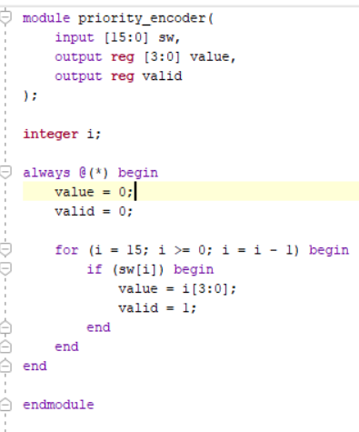
module priority_encoder(
input [15:0] sw,
output reg [3:0] value,
output reg valid
);

integer i;

always @(*) begin
value = 0;
valid = 0;

for (i = 15; i >= 0; i = i - 1) begin
if (sw[i]) begin
value = i[3:0];
valid = 1;
end
end
end

endmodule

Clock Divider:
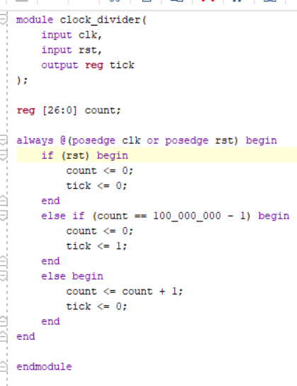

module clock_divider(
input clk,
input rst,
output reg tick
);

reg [26:0] count;

always @(posedge clk or posedge rst) begin
if (rst) begin
count <= 0;
tick <= 0;
end
else if (count == 100_000_000 - 1) begin
count <= 0;
tick <= 1;
end
else begin
count <= count + 1;
tick <= 0;
end
end

endmodule

FSM_counter:
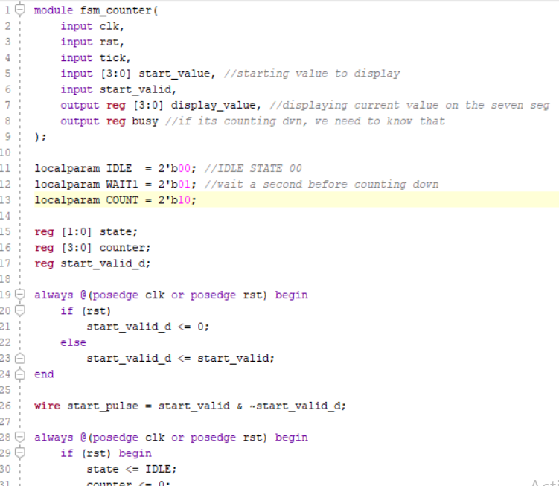

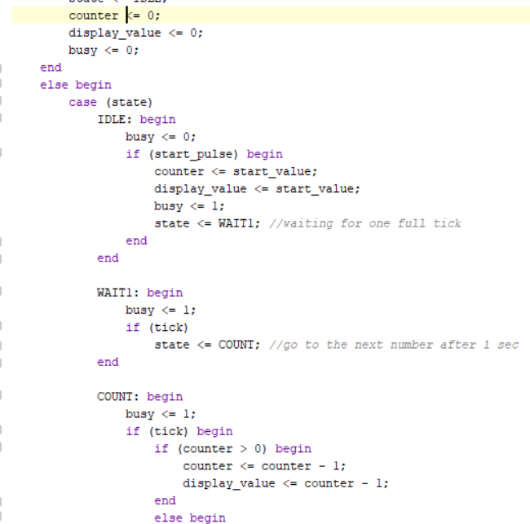

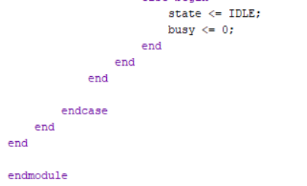

module fsm_counter(
input clk,
input rst,
input tick,
input [3:0] start_value, //starting value to display
input start_valid,
output reg [3:0] display_value, //displaying current value on the seven seg
output reg busy //if its counting dwn, we need to know that
);

localparam IDLE = 2'b00; //IDLE STATE 00
localparam WAIT1 = 2'b01; //wait a second before counting down
localparam COUNT = 2'b10;

reg [1:0] state;
reg [3:0] counter;
reg start_valid_d;

always @(posedge clk or posedge rst) begin
if (rst)
start_valid_d <= 0;
else
start_valid_d <= start_valid;
end

wire start_pulse = start_valid & ~start_valid_d;

always @(posedge clk or posedge rst) begin
if (rst) begin
state <= IDLE;
counter <= 0;
display_value <= 0;
busy <= 0;
end
else begin
case (state)
IDLE: begin
busy <= 0;
if (start_pulse) begin
counter <= start_value;
display_value <= start_value;
busy <= 1;
state <= WAIT1; //waiting for one full tick
end
end

WAIT1: begin
busy <= 1;
if (tick)
state <= COUNT; //go to the next number after 1 sec
end

COUNT: begin
busy <= 1;
if (tick) begin
if (counter > 0) begin
counter <= counter - 1;
display_value <= counter - 1;
end
else begin
state <= IDLE;
busy <= 0;
end
end
end

endcase
end
end

endmodule

LED Module:
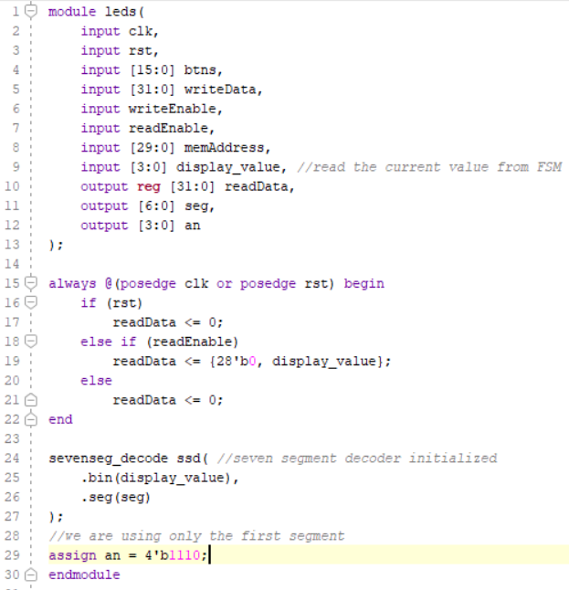

module leds(
input clk,
input rst,
input [15:0] btns,
input [31:0] writeData,
input writeEnable,
input readEnable,
input [29:0] memAddress,
input [3:0] display_value, //read the current value from FSM
output reg [31:0] readData,
output [6:0] seg,
output [3:0] an
);

always @(posedge clk or posedge rst) begin
if (rst)
readData <= 0;
else if (readEnable)
readData <= {28'b0, display_value};
else
readData <= 0;
end

sevenseg_decode ssd( //seven segment decoder initialized
.bin(display_value),
.seg(seg)
);
//we are using only the first segment
assign an = 4'b1110;
endmodule

Seven segment :
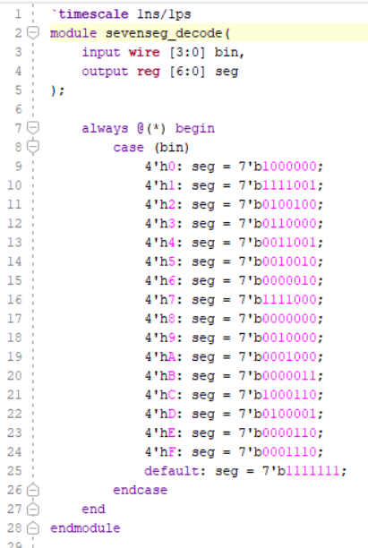

`timescale 1ns/1ps
module sevenseg_decode(
input wire [3:0] bin,
output reg [6:0] seg
);

always @(*) begin
case (bin)
4'h0: seg = 7'b1000000;
4'h1: seg = 7'b1111001;
4'h2: seg = 7'b0100100;
4'h3: seg = 7'b0110000;
4'h4: seg = 7'b0011001;
4'h5: seg = 7'b0010010;
4'h6: seg = 7'b0000010;
4'h7: seg = 7'b1111000;
4'h8: seg = 7'b0000000;
4'h9: seg = 7'b0010000;
4'hA: seg = 7'b0001000;
4'hB: seg = 7'b0000011;
4'hC: seg = 7'b1000110;
4'hD: seg = 7'b0100001;
4'hE: seg = 7'b0000110;
4'hF: seg = 7'b0001110;
default: seg = 7'b1111111;
endcase
end
endmodule
TESTBENCH:
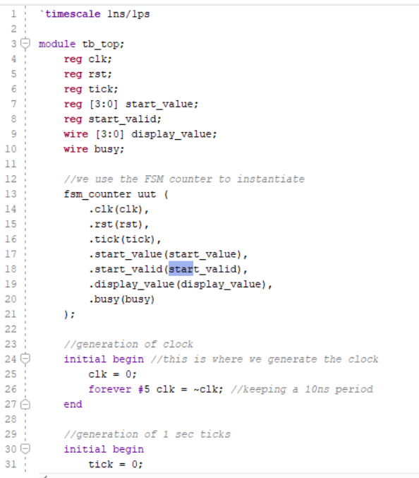
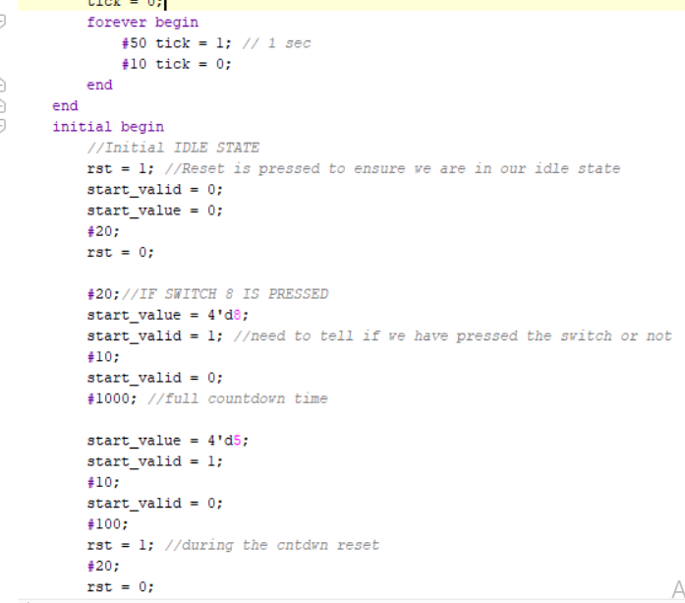

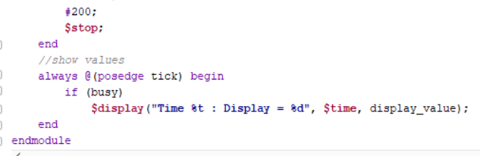
`timescale 1ns/1ps

module tb_top;
reg clk;
reg rst;
reg tick;
reg [3:0] start_value;
reg start_valid;
wire [3:0] display_value;
wire busy;

//we use the FSM counter to instantiate
fsm_counter uut (
.clk(clk),
.rst(rst),
.tick(tick),
.start_value(start_value),
.start_valid(start_valid),
.display_value(display_value),
.busy(busy)
);

//generation of clock
initial begin //this is where we generate the clock
clk = 0;
forever #5 clk = ~clk; //keeping a 10ns period
end

//generation of 1 sec ticks
initial begin
tick = 0;
forever begin
#50 tick = 1; // 1 sec
#10 tick = 0;
end
end

initial begin
//Initial IDLE STATE
rst = 1; //Reset is pressed to ensure we are in our idle state
start_valid = 0;
start_value = 0;
#20;
rst = 0;

//IF SWITCH 8 IS PRESSED
#20;
start_value = 4'd8;
start_valid = 1; //need to tell if we have pressed the switch or not
#10;
start_valid = 0;
#1000; //full countdown time

start_value = 4'd5;
start_valid = 1;
#10;
start_valid = 0;
#100;
rst = 1; //during the cntdwn reset
#20;
rst = 0;
#200;
$stop;
end

//show values
always @(posedge tick) begin
if (busy)
$display("Time %t : Display = %d", $time, display_value);
end

endmodule

Results:

Task 3

XDC file

## =========================================================

## Basys 3 Master XDC

## Signals:

## sw[15:0] - 16 switches

## led[15:0] - 16 LEDs

## seg[7:0] - 7-segment segments + decimal point

## an[3:0] - 7-segment digit enables

## clk - 100 MHz clock

## rst_btn - Center push button

## =========================================================

## =========================================================

## CLOCK

## =========================================================

set_property PACKAGE_PIN W5 [get_ports clk]

set_property IOSTANDARD LVCMOS33 [get_ports clk]

create_clock -add -name sys_clk_pin -period 10.00 \

-waveform {0 5} [get_ports clk]

## =========================================================

## RESET BUTTON

## Basys 3 Center Button

## =========================================================

set_property PACKAGE_PIN U18 [get_ports rst_btn]

set_property IOSTANDARD LVCMOS33 [get_ports rst_btn]

## =========================================================

## SWITCHES

## =========================================================

set_property PACKAGE_PIN V17 [get_ports {sw[0]}]

set_property IOSTANDARD LVCMOS33 [get_ports {sw[0]}]

set_property PACKAGE_PIN V16 [get_ports {sw[1]}]

set_property IOSTANDARD LVCMOS33 [get_ports {sw[1]}]

set_property PACKAGE_PIN W16 [get_ports {sw[2]}]

set_property IOSTANDARD LVCMOS33 [get_ports {sw[2]}]

set_property PACKAGE_PIN W17 [get_ports {sw[3]}]

set_property IOSTANDARD LVCMOS33 [get_ports {sw[3]}]

set_property PACKAGE_PIN W15 [get_ports {sw[4]}]

set_property IOSTANDARD LVCMOS33 [get_ports {sw[4]}]

set_property PACKAGE_PIN V15 [get_ports {sw[5]}]

set_property IOSTANDARD LVCMOS33 [get_ports {sw[5]}]

set_property PACKAGE_PIN W14 [get_ports {sw[6]}]

set_property IOSTANDARD LVCMOS33 [get_ports {sw[6]}]

set_property PACKAGE_PIN W13 [get_ports {sw[7]}]

set_property IOSTANDARD LVCMOS33 [get_ports {sw[7]}]

set_property PACKAGE_PIN V2 [get_ports {sw[8]}]

set_property IOSTANDARD LVCMOS33 [get_ports {sw[8]}]

set_property PACKAGE_PIN T3 [get_ports {sw[9]}]

set_property IOSTANDARD LVCMOS33 [get_ports {sw[9]}]

set_property PACKAGE_PIN T2 [get_ports {sw[10]}]

set_property IOSTANDARD LVCMOS33 [get_ports {sw[10]}]

set_property PACKAGE_PIN R3 [get_ports {sw[11]}]

set_property IOSTANDARD LVCMOS33 [get_ports {sw[11]}]

set_property PACKAGE_PIN W2 [get_ports {sw[12]}]

set_property IOSTANDARD LVCMOS33 [get_ports {sw[12]}]

set_property PACKAGE_PIN U1 [get_ports {sw[13]}]

set_property IOSTANDARD LVCMOS33 [get_ports {sw[13]}]

set_property PACKAGE_PIN T1 [get_ports {sw[14]}]

set_property IOSTANDARD LVCMOS33 [get_ports {sw[14]}]

set_property PACKAGE_PIN R2 [get_ports {sw[15]}]

set_property IOSTANDARD LVCMOS33 [get_ports {sw[15]}]

## =========================================================

## LEDs

## =========================================================

set_property PACKAGE_PIN U16 [get_ports {led[0]}]

set_property IOSTANDARD LVCMOS33 [get_ports {led[0]}]

set_property PACKAGE_PIN E19 [get_ports {led[1]}]

set_property IOSTANDARD LVCMOS33 [get_ports {led[1]}]

set_property PACKAGE_PIN U19 [get_ports {led[2]}]

set_property IOSTANDARD LVCMOS33 [get_ports {led[2]}]

set_property PACKAGE_PIN V19 [get_ports {led[3]}]

set_property IOSTANDARD LVCMOS33 [get_ports {led[3]}]

set_property PACKAGE_PIN W18 [get_ports {led[4]}]

set_property IOSTANDARD LVCMOS33 [get_ports {led[4]}]

set_property PACKAGE_PIN U15 [get_ports {led[5]}]

set_property IOSTANDARD LVCMOS33 [get_ports {led[5]}]

set_property PACKAGE_PIN U14 [get_ports {led[6]}]

set_property IOSTANDARD LVCMOS33 [get_ports {led[6]}]

set_property PACKAGE_PIN V14 [get_ports {led[7]}]

set_property IOSTANDARD LVCMOS33 [get_ports {led[7]}]

set_property PACKAGE_PIN V13 [get_ports {led[8]}]

set_property IOSTANDARD LVCMOS33 [get_ports {led[8]}]

set_property PACKAGE_PIN V3 [get_ports {led[9]}]

set_property IOSTANDARD LVCMOS33 [get_ports {led[9]}]

set_property PACKAGE_PIN W3 [get_ports {led[10]}]

set_property IOSTANDARD LVCMOS33 [get_ports {led[10]}]

set_property PACKAGE_PIN U3 [get_ports {led[11]}]

set_property IOSTANDARD LVCMOS33 [get_ports {led[11]}]

set_property PACKAGE_PIN P3 [get_ports {led[12]}]

set_property IOSTANDARD LVCMOS33 [get_ports {led[12]}]

set_property PACKAGE_PIN N3 [get_ports {led[13]}]

set_property IOSTANDARD LVCMOS33 [get_ports {led[13]}]

set_property PACKAGE_PIN P1 [get_ports {led[14]}]

set_property IOSTANDARD LVCMOS33 [get_ports {led[14]}]

set_property PACKAGE_PIN L1 [get_ports {led[15]}]

set_property IOSTANDARD LVCMOS33 [get_ports {led[15]}]

## =========================================================

## 7-SEGMENT DISPLAY

## seg[0] = CA

## seg[1] = CB

## seg[2] = CC

## seg[3] = CD

## seg[4] = CE

## seg[5] = CF

## seg[6] = CG

## seg[7] = DP

## =========================================================

set_property PACKAGE_PIN W7 [get_ports {seg[0]}]

set_property IOSTANDARD LVCMOS33 [get_ports {seg[0]}]

set_property PACKAGE_PIN W6 [get_ports {seg[1]}]

set_property IOSTANDARD LVCMOS33 [get_ports {seg[1]}]

set_property PACKAGE_PIN U8 [get_ports {seg[2]}]

set_property IOSTANDARD LVCMOS33 [get_ports {seg[2]}]

set_property PACKAGE_PIN V8 [get_ports {seg[3]}]

set_property IOSTANDARD LVCMOS33 [get_ports {seg[3]}]

set_property PACKAGE_PIN U5 [get_ports {seg[4]}]

set_property IOSTANDARD LVCMOS33 [get_ports {seg[4]}]

set_property PACKAGE_PIN V5 [get_ports {seg[5]}]

set_property IOSTANDARD LVCMOS33 [get_ports {seg[5]}]

set_property PACKAGE_PIN U7 [get_ports {seg[6]}]

set_property IOSTANDARD LVCMOS33 [get_ports {seg[6]}]

set_property PACKAGE_PIN V7 [get_ports {seg[7]}]

set_property IOSTANDARD LVCMOS33 [get_ports {seg[7]}]

## =========================================================

## 7-SEGMENT DIGIT ENABLES

## =========================================================

set_property PACKAGE_PIN U2 [get_ports {an[0]}]

set_property IOSTANDARD LVCMOS33 [get_ports {an[0]}]

set_property PACKAGE_PIN U4 [get_ports {an[1]}]

set_property IOSTANDARD LVCMOS33 [get_ports {an[1]}]

set_property PACKAGE_PIN V4 [get_ports {an[2]}]

set_property IOSTANDARD LVCMOS33 [get_ports {an[2]}]

set_property PACKAGE_PIN W4 [get_ports {an[3]}]

set_property IOSTANDARD LVCMOS33 [get_ports {an[3]}]

Timing Summary
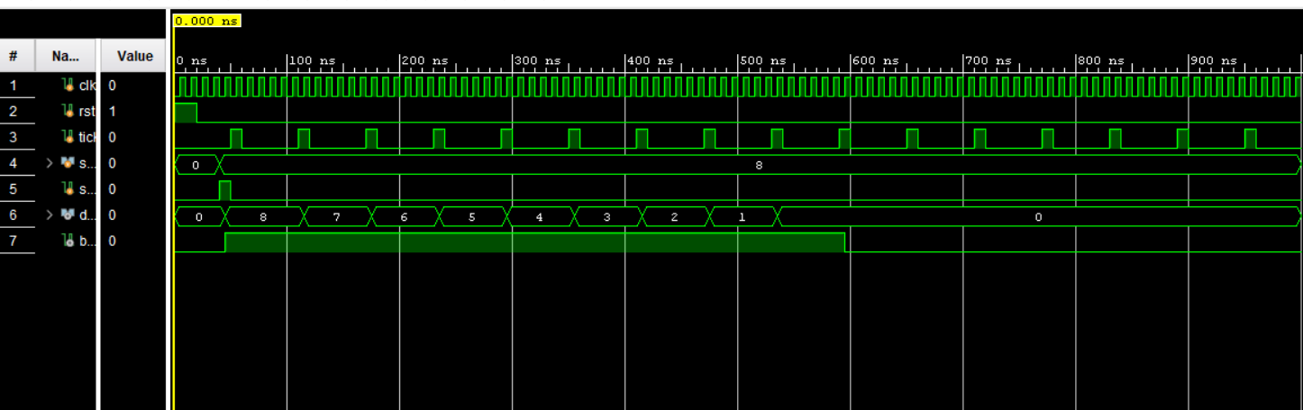

Interpretation:
On each rising edge of clk where tick == 1, the counter decrements by 1

Task 4

RTL Schematic:

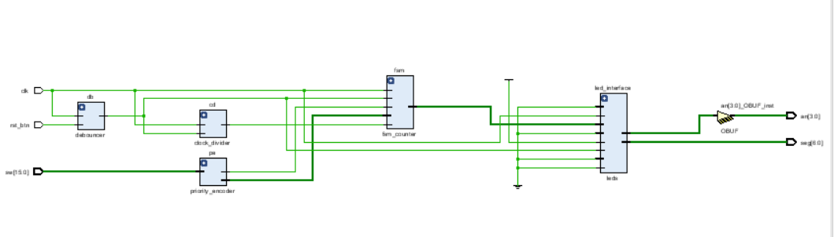

GITHUB LINK
https://github.com/MohammadNaqvi1098/CALabs-Git-mn11062.git

https://github.com/Fakhariqblal/caLAB_git_si11091-main

Lab 05 – Designing FSM Using FPGA Switches and LEDs

Assessment Rubrics

Points Distribution
Task No. | LR2  Code | LR 5  Results | LR11  Design | AR7
Prelab |  | /15 |  | /10 & /10
Task 1 | - | - | /10 | /10 & /10
Task 2 | /15 | /10 |  | /10 & /10
Task 3 |  | /15 |  | /10 & /10
Task 4 |  | /15 |  | /10 & /10
Total Points | /80 |  |  | /20
CLO Mapped | CLO 1
For description of different levels of the mapped rubrics, please refer the provided Lab Evaluation Assessment Rubrics and Affective Domain Assessment Rubrics.
# | Assessment Elements | Level 1: Unsatisfactory  Points 0-1 | Level 2: Developing  Points 2 | Level 3:Good  Points 3 | Level 4:Exemplary  Points 4
LR2 | Program/Code/ Simulation Model/ Network Model | Program/code/simulation model/network model does not implement the required functionality and has several errors. The student is not able to utilize even the basic tools of the software. | Program/code/simulation model/network model has some errors and does not produce completely accurate results. Student has limited command on the basic tools of the software. | Program/code/simulation model/network model gives correct output but not efficiently implemented or implemented by computationally complex routine. | Program/code/simulation /network model is efficiently implemented and gives correct output. Student has full command on the basic tools of the software.
LR5 | Results & Plots | Figures/ graphs / tables are not developed or are poorly constructed with erroneous results. Titles, captions, units are not mentioned. Data is presented in an obscure manner. | Figures, graphs and tables are drawn but contain errors. Titles, captions, units are not accurate. Data presentation is not too clear. | All figures, graphs, tables are correctly drawn but contain minor errors or some of the details are missing. | Figures / graphs / tables are correctly drawn and appropriate titles/captions and proper units are mentioned. Data presentation is systematic.
AR9 | Report | All the in-lab tasks are not included in report and / or the report is submitted too late. | Most of the tasks are included in report but are not well explained. All the necessary figures / plots are not included. Report is submitted after due date. | Good summary of most the in-lab tasks is included in report. The work is supported by figures and plots with explanations. The report is submitted timely. | Detailed summary of the in-lab tasks is provided. All tasks are included and explained well. Data is presented clearly including all the necessary figures, plots and tables.

